Amendments that need to be made
1. There is some confusion in the introduction to the main chapters and in the discussion about the meaning of basic epidemiological terms:
(a) the candidate should propose a formal definition of confounder for example at the end of Chapter 2. Then in substantive chapters (4 to 7) he should specify, based on his formal definition, what confounders might be at work for each analysis. He should identify potential confounders (measured and unmeasured) and note where the models control for these. His current tendency is to define confounders computationally (a posteriori), which is at odds with consensus epidemiological theory.
(b) in the same places he should define effect modifiers formally and then list potential ones of possible importance and note (if measured), if he has investigated that modification and if not why not.
(c) in the same places he should discuss briefly whether or not potential variables are in the causal pathways from temperature to outcomes and the implications of this
(d) these concepts should be finally considered in the Discussion of each substantive chapter in the context of a causal appraisal of the associations
As an example, when he states
“It has also been argued that pollution should not be a confounder of temperature mortality association, as adjusting for pollution excludes the interaction between temperature and pollution” he should be more analytical and discuss the potential role of air pollution as a confounder, as an intermediate variable in the causal pathway and as an effect modifier.
I have added my description of confounders, effect modifiers and mediators, in Section 5.5 on pgs. XX-XX. I have also listed potential variables of note, and the implications of these on my study and potential future work, in Section XX of Chapter 8, the Discussion Chapter.
Chapter 4’s analysis is purely statistical and not causal inference. Therefore, I have not included a description of potential confounders out of Chapter 4’s discussion.

Confounders, effect modifiers and mediators

Confounders
A confounder is a variable that influences the exposure variable (in my case anomalous temperature) as well as the outcome variable (in my case death rates).¹ Without adjusting for confounders in an analysis, the real effect of the original exposure could lead to an over- or underestimation of the effect of an exposure on an outcome, depending on how the confounders are associated with the original exposure and the outcome.
Figure 33 displays a Directed Acyclic Graph (DAG). DAGs are commonly used in the epidemiological community to identify variables which must be measured and controlled for to obtain unconfounded effect estimates.² In the DAG in Figure 33, air pollution is not a confounder, as its variation does not influence temperature. Rather, temperature can influence the level of air pollution. However, both air pollution and temperature are exposures manifested by the physics of the atmosphere on Earth, summarised in Figure 33 by the term ‘weather regimes’. If appropriate adjustments cannot be made to account for the common influence of weather regimes, then air pollution should be adjusted for in my statistical model. In my model, I have attempted to adjust for weather regimes, which vary by month of the year, by stratifying my analysis by month (Section 5.4). I acknowledge, however, that this may not fully capture the entirety of the variation that weather regimes may have on air pollution and temperature exposure values. I discuss this further in Section 8.4 of Chapter 8.
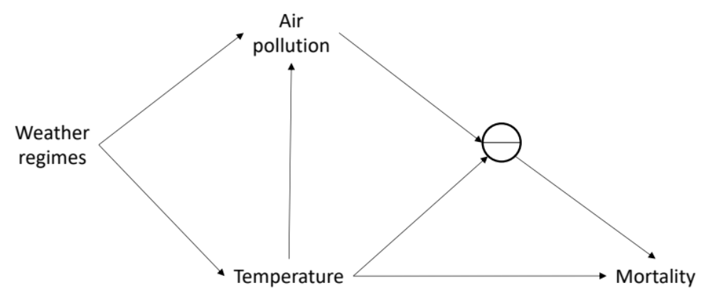
Figure 33. DAG describing the potential confounding and effect modification of air pollution on a study of tempearture and mortality. The pie symbol represents the potential effect modification between air pollution and temperature.

Effect modifiers
Effect modification is where the magnitude of an exposure effect varies across levels of another variable.¹ A common example of an effect modifier is age, whereby an exposure effect on an outcome may be different depending on how old or young a person is. Figure 33 displays a pie symbol, seen as a daughter of both air pollution and temperature, denoting the potential effect modification of temperature by temperature, styled after recent DAG proposals by VanderWeele. [ref] In the model I used here for my thesis, I accounted for the potential effect modification by month, sex and age group (Equation 4) and by state (Equation 9), based on previous research explained in Chapter 2. In my thesis, I did not examine the effect modification by air pollution levels; rather, my results in Chapters 6 and 7 give the average effect across distributions of air pollution levels. This is analogous to summarising various age-modified risks by a single value to represent risk across all ages, common in epidemiological studies. I discuss how further work could include air pollution as an effect modifier in Section 8.4 of Chapter 8, as well as other potential effect modifiers which may be worth exploring.

Mediators
A mediator is a variable along a causal pathway between the exposure and the outcome.¹ For example, warmer temperatures may cause people to drink more alcohol, but alcohol also impairs a driver’s ability to drive without getting into accidents. Increases in temperature and alcohol levels in a driver’s blood both increase the chances of dying, but increases in temperature also affect the potential for the population to drink alcohol.
Figure 33 shows air pollution as a mediator, recognised by a large body of research,^{3–8} as well as an effect modifier and potential confounder. I discuss other potential mediators, and the implications of this on the interpretation of my results, in Section 8.4 of Chapter 8.

Works cited
1. Rothman, K. J., Greenland, S. & Associate, T. L. L. Modern Epidemiology: 3rd Edition. Lippincott Williams & Wilkins (2014). doi:10.1002/hast.292
2. Greenland, S., Pearl, J. & Robins, J. M. Causal diagrams for epidemiologic research. Epidemiology (1999). doi:10.1097/00001648-199901000-00008
3. Dockery, D. W. et al. An association between air pollution and mortality in six U.S. cities. N. Engl. J. Med. 329, 1753–9 (1993).
4. Pope, C. A. et al. Lung cancer, cardiopulmonary mortality, and long-term exposure to fine particulate air pollution. JAMA 287, 1132–1141 (2002).
5. Pope, C. A. & Dockery, D. W. Health effects of fine particulate air pollution: lines that connect. J. Air Waste Manag. Assoc. (2006). doi:10.1080/10473289.2006.10464485
6. Brook, R. D. et al. Particulate matter air pollution and cardiovascular disease: an update to the scientific statement from the american heart association. Circulation (2010). doi:10.1161/CIR.0b013e3181dbece1
7. Burnett, R. et al. Global estimates of mortality associated with long-term exposure to outdoor fine particulate matter. Proc. Natl. Acad. Sci. (2018). doi:10.1073/pnas.1803222115
8. Krewski, D. et al. Extended follow-up and spatial analysis of the American Cancer Society study linking particulate air pollution and mortality. Res. Rep. Health. Eff. Inst. (2009).

